**Objectives**

**Design our first topology with configured static routing**

* Ensure you’ve reviewed the lecture slides, module videos and textbook first.
* The instructions for Part One are demonstrated in the video “08v Static Routing Demo”
* Read over the entire lab before proceeding. Follow instructions carefully. Do not make assumptions.
* Per the lecture, it may be helpful to draw the topology diagram first and label the ports and subnet addresses.
* Do not over configure!

**Part 1 - Create the Topology**  
 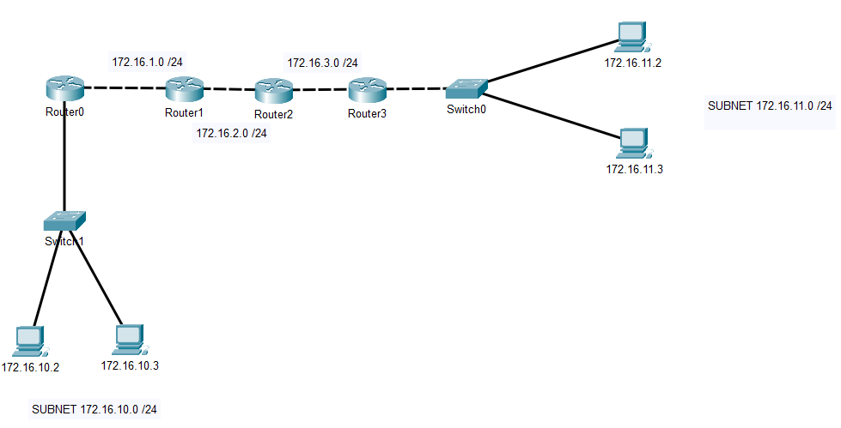

* Add a textbox with your name, Class ID , and “LAB 08A”
* Note: Use a 4331 Router configured with 3 ports
* Configure each PC’s IP address
* Configure each router’s ports with the **IP ADDRESS** command. It may be helpful to use the table on the next page
* Configure each router to have a static route to 172.16.10.0 /24 and to 172.16.11.0 /24.
* In simulation mode: Ping from PC 172.16.10.2 to PC 172.16.11.2   
  The request ICMP packet should move through the routers to the destination and return a response ICMP packet back.
* If the packet doesn’t flow, debug the router where it stops and the next hop.
  1. Are the IP addresses configured correctly?
  2. Did you use the correct subnet mask 255.255.0.0?
  3. Is the IP ROUTE command correct?
  4. Are you cabled to the correct port?

|  |  |  |  |
| --- | --- | --- | --- |
| **Router** | **Port** | **IP Address** |  |
| R0 | 0 |  |  |
|  | 1 |  |  |
|  | 2 |  |  |
| R1 | 1 |  |  |
|  | 2 |  |  |
| R2 | 1 |  |  |
|  | 2 |  |  |
| R3 | 1 |  |  |
|  | 2 |  |  |
|  | 3 |  |  |

**Part 2 – Configure Additional Static Routes**

The best practice for learning static routing is to do more configuring.

**A. Add another subnet and configure all routers to have a static route to it.** 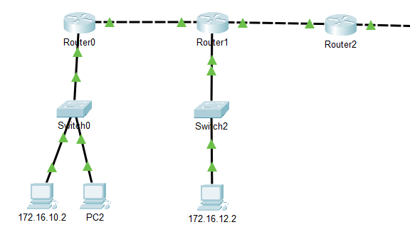

1. Add a new switch to Router1 , Port 0
2. Configure the PC as 172.16.**12**.2 /24
3. Configure R1 Port 0 as 172.16.12.1 /24
4. Configure all routers for the new subnet 172.16.12.0   
   R0 : **IP ROUTE 172.16.12.0 255.255.255.0 172.16.1.2**    
   R2 : **IP ROUTE 172.16.12.0 255.255.255.0 172.16.2.1**    
   R3 : **IP ROUTE 172.16.12.0 255.255.255.0 172.16.3.1**
5. Ensure that all PC’s can ping each other!

**B. Add two more subnets and configure all routers to have a static route to them.**

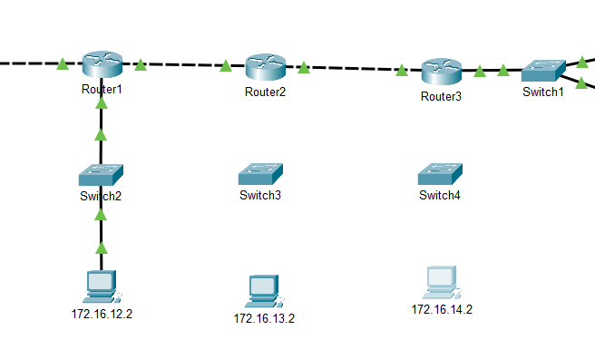 **Lab Completion**

* Save your PKT file : L08A-*lastname*.PKT.
* Submit only the PKT file in iLearn. *You do not have to write up a lab for this week.*

*\*\*\* End of Lab 8a \*\*\**